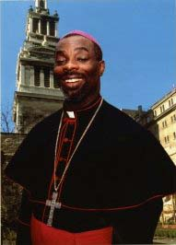

Most Rev. Bishop Vincent Darius

Bishop of St. George’s-in-.Grenada

Bishop's Residence, The Villa,

P.O. Box 375, St. George's, Grenada

Most Rev. Bishop Vincent Darius

has after discussions with Glenda La Fleur 2nd December 2013 approved that the Living Rosary can be introduced in congregations and religious associations throughout Grenada.